**Open RAN**



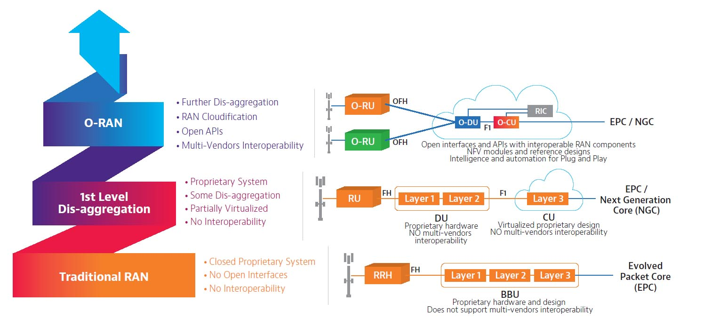

An Open Radio Access Network (O-RAN) is a disaggregated approach to deploying mobile fronthaul and midhaul networks built entirely on cloud native principles. O-RAN underscores streamlined 5G RAN performance objectives through the common attributes of efficiency, intelligence and versatility. Open RAN deployed at the network edge will benefit 5G applications such as autonomous vehicles and the IoT, support network slicing use cases effectively, and enable secure and efficient over-the-air firmware upgrades.

O-RAN is an evolution of the Next Generation RAN (NG-RAN) architecture, first introduced by the GSMA’s 3GPP in their release 15 (5G version 1) technical specification TS 38.401. The O-RAN Alliance formed to undertake the advancement of NG-RAN philosophies, expanding on the scope of what was originally outlined by the 3GPP. Comprising over 1601 member companies, the O-RAN alliance issues specifications and releases open source software under the auspices of the Linux Foundation.

**Service Management and Orchestration (SMO):**

SMO must ensure the Non-RT RIC to access specific functionalities related to RAN optimization actions like in particular collecting Performance Measurements (PM) through O1 and O2 interfaces.

In addition to this the SMO must take care of the orchestration of the Network Functions Virtualization Infrastructure (NFVI), managing the life cycle of O-RAN network elements (Near-RT RIC, O-CU, O-DU, O-RU) which can be either Virtual Network Functions (VNFs) hosted in specific location of the O-Cloud infrastructure or Physical Network Functions (PNFs) exposed by cell sites.

For non-virtualized parts, typically O-RU functionalities which are related to area coverage and need to be placed at cell sites, the SMO supports the deployment of physical network elements on dedicated physical resources with management through the O1 interface.

For virtualized network elements, the SMO has the capability to interact with the O-Cloud to perform network element life cycle management, for

example it can instantiate the virtualized network element on the target infrastructure through the O2 interface or indicate the selected geo-location for each VNF to be instantiated.

Finally the Service Management and Orchestration framework must be able

to support the communication between the deployed network elements and so

it is in charge of IP addressing, network reconfiguration and system updates.

Then to guarantee various deployment solutions the Operation and Maintenance architecture defined by O-RAN describes in details the requirements

needed such that the SMO framework can be provided by third-party Network

Management Systems (NMS) or orchestration platforms like for example the

Linux Foundation’s Open Network Automation Platform (ONAP) [20].

**near-RT RIC:** O-RAN near-real-time RAN Intelligent Controller: a logical function that enables near-real-time control and optimization of O-RAN elements and resources via fine-grained data collection and actions over E2 interface.

**non-RT RIC:** O-RAN non-real-time RAN Intelligent Controller: a logical function that enables non-real-time control and optimization of RAN elements and resources, AI/ML workflow including model training and updates, and policy-based guidance of applications/features in near-RT RIC.

**O-CU:** O-RAN Central Unit: a logical node hosting RRC, SDAP and PDCP protocols

RRC= Radio Resource Control

SDAP= Service Data Adaptation Protocol

PDCP= Packet Data Convergence Protocol

**O-CU-CP:** O-RAN Central Unit – Control Plane: a logical node hosting the RRC and the control plane part of the PDCP protocol.

**O-CU-UP:** O-RAN Central Unit – User Plane: a logical node hosting the user plane part of the PDCP protocol and the SDAP protocol.

**O-DU:** O-RAN Distributed Unit: a logical node hosting RLC/MAC/High-PHY layers based on a lower layer functional split.

**O-RU:** O-RAN Radio Unit: a logical node hosting Low-PHY layer and RF processing based on a lower layer functional split. This is similar to 3GPP’s “TRP” or “RRH” but more specific in including the Low-PHY layer (FFT/iFFT, PRACH extraction).

**O1:** Interface between management entities in Service Management and Orchestration Framework and O-RAN managed elements, for operation and management, by which FCAPS management, Software management, File management shall be achieved.

**O1*:** Interface between Service Management and Orchestration Framework and Infrastructure Management Framework supporting O-RAN virtual network functions.

O-RAN ALLIANCE is a world-wide community of mobile operators, vendors, and research & academic institutions operating in the Radio Access Network industry. As the RAN is an essential part of any mobile network, O-RAN ALLIANCE's mission is to re-shape the industry towards more intelligent, open, virtualized and fully interoperable mobile networks. The new O-RAN standards enable a more competitive and vibrant RAN supplier ecosystem with faster innovation to improve user experience. O-RAN-compliant mobile networks will at the same time improve the efficiency of RAN deployments as well as operations by the mobile operators. To achieve this, O-RAN ALLIANCE publishes new RAN specifications, releases open software for the RAN, and supports its members in integration and testing of their implementations. For more information please visit www.o-ran.org.

Link: <https://www.o-ran.org/>

**Releases**

1. A Release (Amber release)>>>>>>>>>>>Nov 2019
2. B Release (Bronze Release) >>>>>>><>>Jun 2020
3. C Release (Cherry Release)>>>>>>>>>>> Dec 2020
4. D Release (Dawn Release) >>>>>>>>>>Jul 2021
5. E Release (Emerald Release)>>>>>>>><Dec 2021
6. F Release >>>>>>>>>>Jul 2022
7. G Release >>>>>>>>>> Dec 2022
8. H Release (Upcoming) >>>>>>>>>>>

**F Release**

<https://wiki.o-ran-sc.org/display/REL/F+Release>

F Release:

The F release is completed and its source code is maintained within the master branch of each repo.

* Near-Real-time RIC X-APPs (RICAPP)
* Near-Real-time RAN Intelligent Controller Platform (E2 Interface) (RICPLT)
* Non-Real-time RIC (A1 & R1 Interfaces) (NONRTRIC)
* Operation and Maintenance (OAM)
* O-RAN Central Unit (OCU)
* O-DU High
* O-DU Low
* Simulators (SIM)
* Infrastructure (INF)
* Integration and Test (INT)
* Documentation (DOC)
* Service Management and Orchestration (SMO)

**Near-Real-time RIC X-APPs (RICAPP):** Expand the community working on open source xApps for O-RAN SC. Enhance the set of open source xApps in support of the R-SAC use cases (traffic steering, network slicing) as well new use cases. Update and enhance existing xApps to take advantage of the new features in xApp SDK (implemented by the xApp frameworks in C++, go, and python).

**Non-Real-time RIC (A1 & R1 Interfaces) (NONRTRIC):**

* The primary goal of Non-RT RIC is to support intelligent RAN optimization by providing policy-based guidance, ML model management and enrichment information to the near-RT RIC function so that the RAN can optimize, e.g., RRM under certain conditions.
* It can also perform intelligent radio resource management function in non-real-time interval (i.e., greater than 1 second).
* Non-RT RIC can use data analytics and AI/ML training/inference to determine the RAN optimization actions for which it can leverage SMO services such as data collection and provisioning services of the O-RAN nodes.
* Non-RT-RIC will define and coordinate rApps (Non-RT-RIC applications) to perform Non-RT-RIC tasks.
* Non-RT-RIC will host the A1 interface (between NONRTRIC & near-RT RICs )
* Non-RT-RIC will also host the new R1 interface (between rApps and SMO/NONRTRIC services)

**Read F-Release in details**

**r-APP**

2.4.2 xApps/rApps

These applications are developed by specialised software providers that do not have to be part of the RIC provider itself. These “xApps” (in near-RT RIC) band “rApps” (in non-RT RIC) are intended to enable innovation in the form of RAN control algorithms and to attract software innovators to the mobile sector. xApps and rApps have the ability to process data from a RAN much faster than today's vendor-proprietary systems or centralised SON methods.

As a result, a differentiated network experience can be created, with performance tailored to specific service types, user groups or locations. Conversely, the services provided by a RIC consist of either xApps or rApps, or a combination of both. There is no definable limit on the types of xApps or rApps that can be built, The rAPP protocol for non-real time RAN includes the following key components:

**Connection management:** This component manages the establishment, maintenance, and release of connections between the mobile device and the RAN. It also handles the negotiation of connection parameters such as bandwidth and quality of service (QoS).

**Security:** The rAPP protocol provides authentication and encryption mechanisms to ensure the security and privacy of the data transmitted between the mobile device and the RAN.

**Data transfer:** This component manages the transfer of non-real time data between the mobile device and the RAN. It includes mechanisms for error detection and correction, flow control, and congestion control.

**Session management:** This component manages the overall session between the mobile device and the RAN, including the initiation, maintenance, and termination of the session.

Overall, the rAPP protocol for non-real time RAN provides a standardized way for mobile devices to communicate with the RAN in a secure and efficient manner.

Kubernetes: Kubernetes is an open-source container orchestration system for automating software deployment, scaling, and management.[3][4] Originally designed by Google, the project is now maintained by the Cloud Native Computing Foundation.

Helm: Helm is a package manager for Kubernetes. Helm helps you manage Kubernetes applications — Helm Charts help you define, install, and upgrade even the most complex Kubernetes application.